OSSP
Practical Session 10: Investigating Inodes, Hard Links and Symbolic Links in Linux
Aim
To investigate Linux inode structures using ls -i, stat, and find, and to create hard and symbolic links to understand their effect on inode allocation and file metadata.
Objectives
- Examine inode numbers and file metadata using Linux commands.
- Create and compare hard links and symbolic links.
- Understand how links affect inode allocation, link counts, and file storage.
- Analyze the behavior of files when the original name is deleted.

1. Background: What is an Inode?
In Linux, an inode (index node) is a filesystem data structure that stores metadata about a file.
An inode generally contains:
- File type
- File permissions
- Owner and group
- File size
- Timestamps
- Number of hard links
- References to data blocks
An inode does not normally store the filename.
The relationship is approximately:
Directory
|
+---- filename ───────→ inode
|
+---- metadata
|
+---- data blocks
For example:
file1.txt ─────┐
↓
inode 12345
|
↓
File contents
2. Create a Test File
Create a working directory:
mkdir inode_lab
cd inode_lab
Create a file:
echo "Linux inode investigation" > original.txt
Check its inode number:
ls -i original.txt
Example:
1234567 original.txt
Here:
1234567
is the inode number.
The actual inode number will be different on your system.
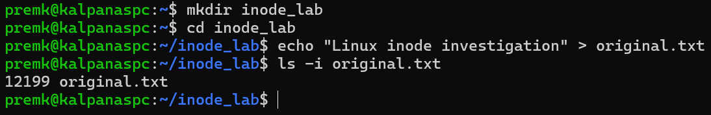

3. Investigate the Inode Using stat
Run:
stat original.txt
Typical output:
File: original.txt
Size: 25
Blocks: 8
IO Block: 4096 regular file
Device: 00h/0d Inode: 1234567
Links: 1
Access: (0644/-rw-r--r--)
Uid: (1000/user)
Gid: (1000/user)
Access: 2026-09-22 09:00:00
Modify: 2026-09-22 09:00:00
Change: 2026-09-22 09:00:00
Birth: ...
Important fields:
Field | Meaning
File | Filename
Size | File size in bytes
Blocks | Disk blocks allocated
Inode | Inode number
Links | Number of hard links
Access | Permissions
Uid | File owner
Gid | File group
Access | Last access time
Modify | Last content modification
Change | Last metadata change
The most important fields for this experiment are:
Inode: 1234567
Links: 1
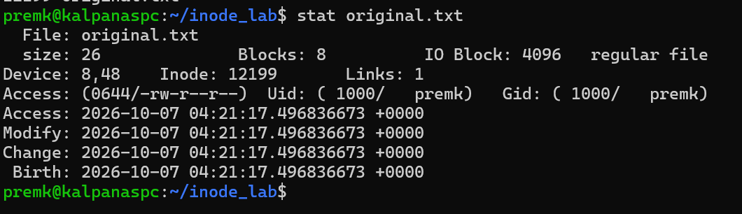
4. Investigate Using ls -li
Run:
ls -li
Example:
1234567 -rw-r--r-- 1 user user 25 Sep 22 09:00 original.txt
The -i option displays the inode number.
The output can be interpreted as:
inode permissions links size filename
↓ ↓ ↓ ↓ ↓
1234567 -rw-r--r-- 1 25 original.txt
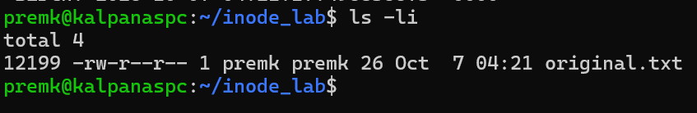
5. Create a Hard Link
Create a hard link:
ln original.txt hardlink.txt
Now execute:
ls -li
Example:
1234567 -rw-r--r-- 2 user user 25 Sep 22 09:00 hardlink.txt
1234567 -rw-r--r-- 2 user user 25 Sep 22 09:00 original.txt
Notice that both filenames have the same inode number:
original.txt ───┐
├──→ inode 1234567
hardlink.txt ───┘
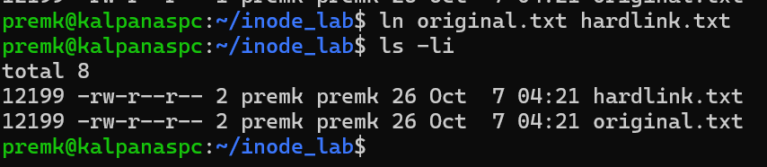
The link count has also changed:
Links: 2
Check:
stat original.txt
stat hardlink.txt
Both refer to the same inode.
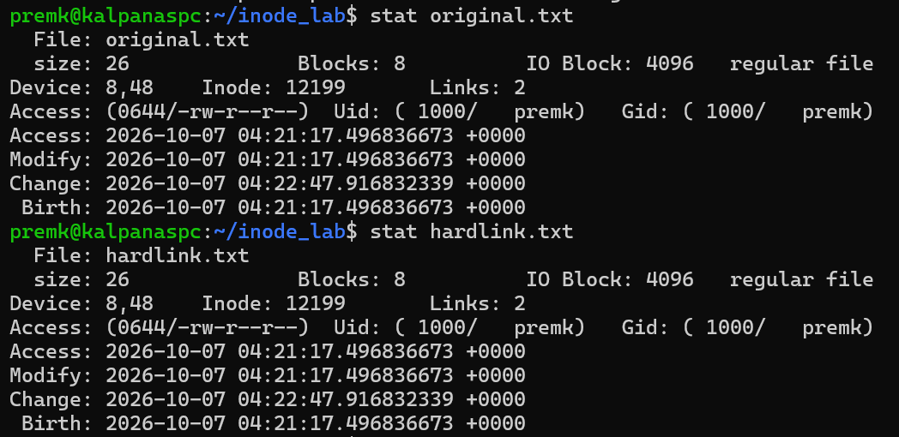
6. Demonstrate That Both Names Access the Same Data
Display the contents:
cat original.txt
cat hardlink.txt
Both produce:
Linux inode investigation
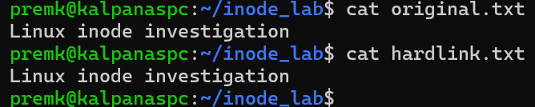
Now modify the file through the hard link:
echo "Modified through hard link" >> hardlink.txt
Check the original:
cat original.txt
Output:
Linux inode investigation
Modified through hard link
This happens because both filenames refer to the same inode and same data blocks.
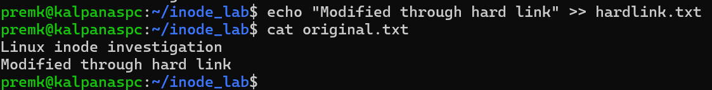
7. Delete the Original Filename
Now remove:
rm original.txt
Check:
ls -li
The hard link still exists:
1234567 -rw-r--r-- 1 user user ... hardlink.txt
The data is still accessible:
cat hardlink.txt
Why?
Because deleting original.txt removes only one directory entry.
The inode's link count changes:
2 → 1
The inode and data remain because one hard link still refers to them.
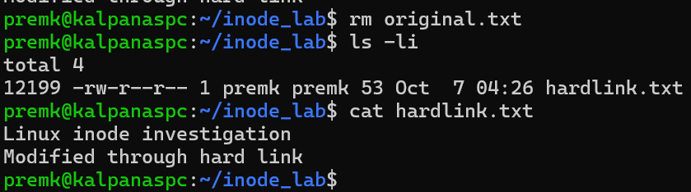
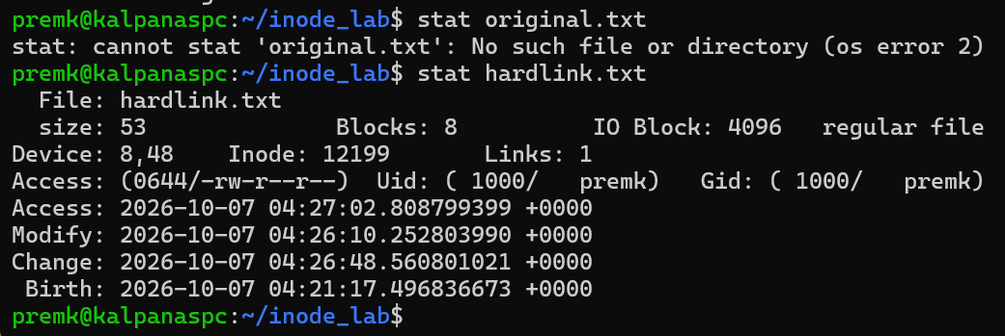Only when the link count reaches zero can the filesystem reclaim the inode and associated data blocks, subject to the file still being open by a process.
8. Create a Symbolic Link
First create another file:
echo "Symbolic link demonstration" > original.txt
Create a symbolic link:
ln -s original.txt symlink.txt
Now:
ls -li
Example:
1234568 -rw-r--r-- 1 user user 28 Sep 22 09:05 original.txt
1234569 lrwxrwxrwx 1 user user 12 Sep 22 09:05 symlink.txt -> original.txt
Notice the important difference:
original.txt → inode 1234568
symlink.txt → inode 1234569
A symbolic link has its own inode.
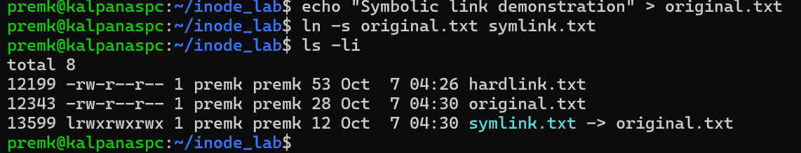
9. Compare Hard Link and Symbolic Link
Run:
stat original.txt
stat hardlink.txt
stat symlink.txt
You can observe:
Hard link
original.txt ───→ inode A
hardlink.txt ───→ inode A
Symbolic link
original.txt ───→ inode A
symlink.txt ───→ inode B ───→ "original.txt" ───→ inode A
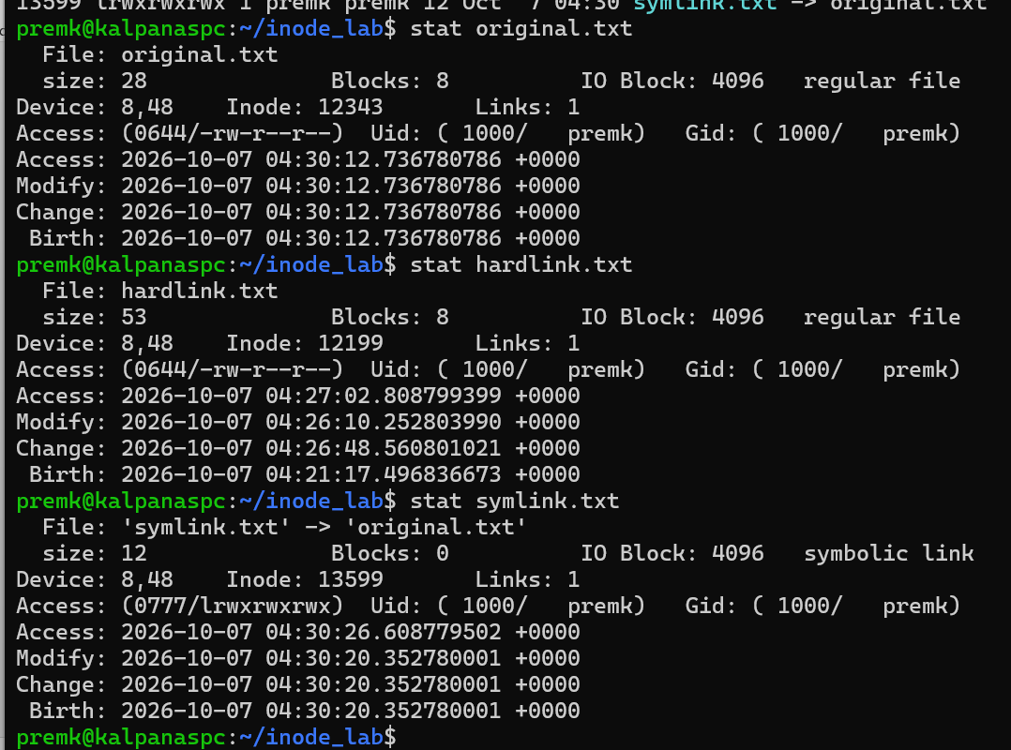
10. Examine Symbolic Link with stat
Use:
stat symlink.txt
To examine the link itself rather than its target:
stat -L symlink.txt
The difference is important.
Without -L
stat symlink.txt
reports information about the symbolic link.
With -L
stat -L symlink.txt
follows the link and reports information about the target.
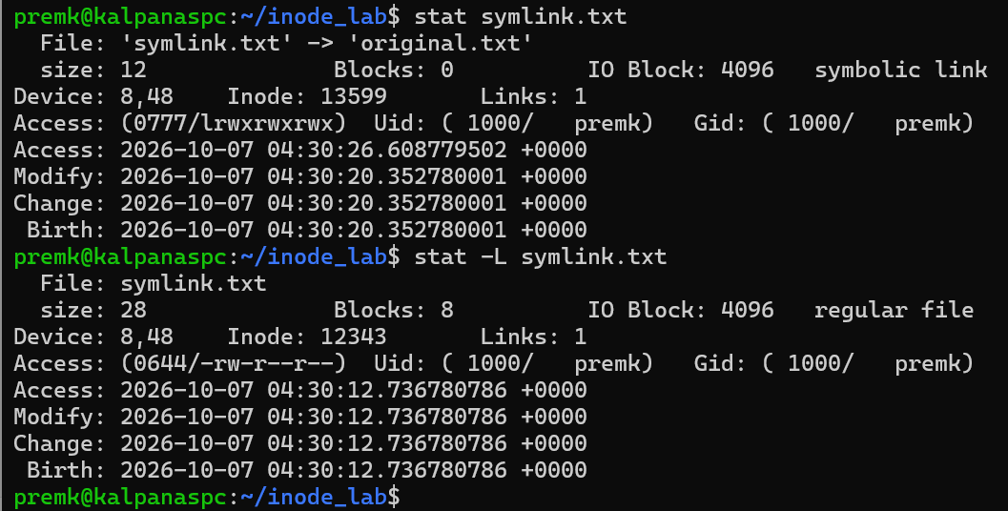
You can also use:
readlink symlink.txt
Output:
original.txt
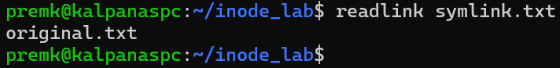
11. Using find to Investigate Inodes
Find a file by inode number
Suppose:
ls -i hardlink.txt
returns:
1234567 hardlink.txt
Then:
find . -inum 1234567
may return:
./hardlink.txt
./another-hardlink.txt
This is useful for identifying all directory entries referring to the same inode.
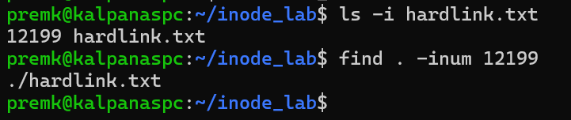
Find symbolic links
find . -type l
Example:
./symlink.txt
Display symbolic-link targets
find . -type l -ls
Example:
1234569 ... ./symlink.txt -> original.txt
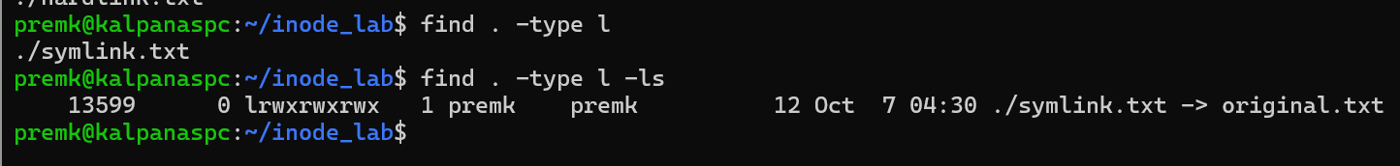
12. Observe the Effect on Inode Allocation
Create the original file:
echo "Hello" > file1
Check:
ls -li file1
Suppose:
1001 file1
Create a hard link
ln file1 file2
Check:
ls -li file1 file2
Example:
1001 file1
1001 file2
No new inode is allocated.
Only the directory gets another name pointing to inode 1001.
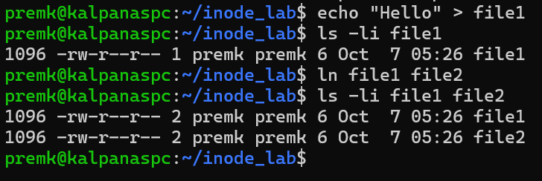
Create a symbolic link
ln -s file1 file3
Check:
ls -li file1 file2 file3
Example:
1001 file1
1001 file2
1002 file3 -> file1
Here, a new inode (1002) is allocated for the symbolic link.
So:
Hard link:
file1 ──┐
├──→ inode 1001
file2 ──┘

Symbolic link:
file3 → inode 1002 → "file1" → inode 1001
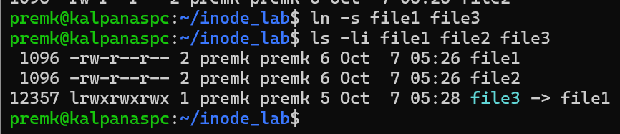
13. Demonstrate Broken Symbolic Links
Remove the target:
rm file1
Now:
ls -l file3
You may see:
file3 -> file1
but the target no longer exists.
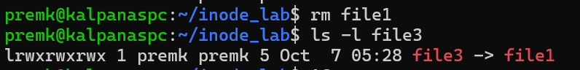
Try:
cat file3
Output:
cat: file3: No such file or directory
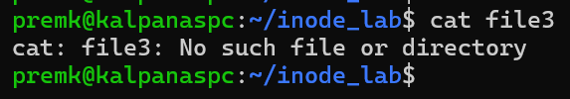
The symbolic link has become a dangling/broken symbolic link.
A hard link would not have this problem because it refers directly to the inode.

14. Useful Commands
Command | Purpose
ls -i file | Display inode number
ls -li | Display inode + detailed information
stat file | Detailed inode/file metadata
stat -L link | Follow symbolic link
find . -inum N | Find directory entries with inode N
find . -type l | Find symbolic links
find . -type f | Find regular files
ln file link | Create hard link
ln -s file link | Create symbolic link
readlink link | Display symbolic-link target
rm link | Remove a link

Experiment: File I/O Using mmap() and Comparison with read()/write()
Aim
To develop a C program that performs file reading and writing using memory-mapped I/O (mmap()) and compare it with traditional read()/write() operations in terms of efficiency and implementation complexity.
Objectives
- Understand how mmap() maps a file into a process's virtual address space.
- Perform file reading and modification using memory-mapped I/O.
- Implement the same operation using read()/write().
- Compare both approaches based on execution time, system calls, and programming complexity.
1. Concept of mmap()
Normally, file reading is performed as:
Disk
↓
read()
↓
Kernel buffer
↓
User buffer
↓
Program
With mmap(), the file is mapped into the process's virtual address space:
File
↓
mmap()
↓
Virtual Memory
↓
Program accesses memory directly
The operating system loads required file pages into physical memory as they are accessed.
Syntax
void *mmap(void *addr,
size_t length,
int prot,
int flags,
int fd,
off_t offset);
For example:
char *data = mmap(NULL, file_size,
PROT_READ | PROT_WRITE,
MAP_SHARED,
fd, 0);
After mapping, the file can be accessed like an array:
printf("%c", data[0]);
data[0] = 'A';
2. Program Using mmap()
The following program:
- Opens a file.
- Determines its size.
- Maps the file into memory.
- Reads the contents through the mapped region.
- Modifies the contents.
- Uses msync() to synchronize changes with the file.
- Unmaps the file.
mmap_file.c
#include <stdio.h>
#include <stdlib.h>
#include <fcntl.h>
#include <unistd.h>
#include <sys/mman.h>
#include <sys/stat.h>
#include <string.h>

int main(void)
{
int fd;
struct stat st;
char *data;
/* Open file for reading and writing */
fd = open("data.txt", O_RDWR);
if (fd == -1)
{
perror("open");
exit(EXIT_FAILURE);
}
/* Obtain file size */
if (fstat(fd, &st) == -1)
{
perror("fstat");
close(fd);
exit(EXIT_FAILURE);
}
if (st.st_size == 0)
{
printf("File is empty.\n");
close(fd);
return 0;
}

/* Map file into memory */
data = mmap(NULL,
st.st_size,
PROT_READ | PROT_WRITE,
MAP_SHARED,
fd,
0);

if (data == MAP_FAILED)
{
perror("mmap");
close(fd);
exit(EXIT_FAILURE);
}
/* Read file through memory mapping */
printf("Original file contents:\n");
fwrite(data, 1, st.st_size, stdout);
printf("\n\nModifying file...\n");
/* Modify first 5 characters.
* Make sure the file contains at least 5 bytes.
*/
if (st.st_size >= 5)
{
memcpy(data, "HELLO", 5);
}
/* Synchronize changes with the file */
if (msync(data, st.st_size, MS_SYNC) == -1)
{
perror("msync");
}
printf("File modified using mmap().\n");
/* Remove mapping */
if (munmap(data, st.st_size) == -1)
{
perror("munmap");
}
close(fd);
return 0;
}
3. Create the Input File
Create a test file:
echo "Linux memory mapped file I/O demonstration" > data.txt
Compile:
gcc -Wall -Wextra -g mmap_file.c -o mmap_file
Run:
./mmap_file
Possible output:
Original file contents:
Linux memory mapped file I/O demonstration

Modifying file...
File modified using mmap().

Now check the file:
cat data.txt
Output:
HELLO memory mapped file I/O demonstration
The modification was made directly through the mapped memory region.
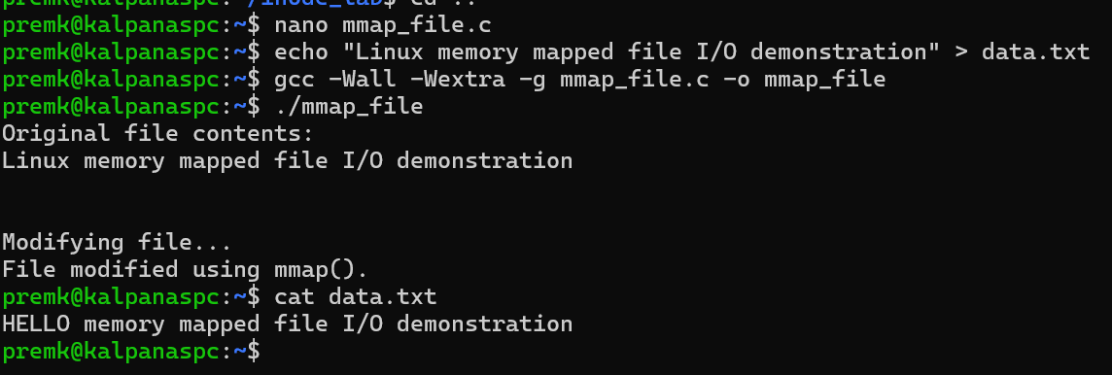
4. How the Program Works
Step 1: Open the file
fd = open("data.txt", O_RDWR);
O_RDWR is required because the program both reads and modifies the file.
Step 2: Obtain file size
fstat(fd, &st);
The size is available as:
st.st_size
The mapping must cover the region that will be accessed.
Step 3: Map the file
data = mmap(NULL,
st.st_size,
PROT_READ | PROT_WRITE,
MAP_SHARED,
fd,
0);
Important arguments:
Argument | Meaning
NULL | Kernel chooses mapping address
st.st_size | Number of bytes to map
PROT_READ | Pages can be read
PROT_WRITE | Pages can be modified
MAP_SHARED | Changes can be reflected in the file
fd | File descriptor
0 | Mapping starts at file offset 0
Step 4: Access the file like memory
Instead of:
read(fd, buffer, size);
we can simply access:
data[0]
data[1]
data[2]
For example:
data[0] = 'H';
modifies the corresponding byte in the mapped file.
Step 5: Synchronize changes
msync(data, st.st_size, MS_SYNC);
This requests that modifications in the mapped region be synchronized with the underlying file.
Step 6: Unmap
munmap(data, st.st_size);
This removes the mapping from the process's virtual address space.

5. Traditional read()/write() Version
Now perform the same modification using traditional system calls.
read_write_file.c
#include <stdio.h>
#include <stdlib.h>
#include <fcntl.h>
#include <unistd.h>
#define BUFFER_SIZE 4096
int main(void)
{
int fd;
ssize_t bytes_read;
char buffer[BUFFER_SIZE];
/* Open file */
fd = open("data.txt", O_RDWR);
if (fd == -1)
{
perror("open");
exit(EXIT_FAILURE);
}
/* Read file */
bytes_read = read(fd, buffer, BUFFER_SIZE - 1);
if (bytes_read == -1)
{
perror("read");
close(fd);
exit(EXIT_FAILURE);
}
buffer[bytes_read] = '\0';
printf("Original file contents:\n%s\n", buffer);

/*
* Move file offset to beginning
*/
if (lseek(fd, 0, SEEK_SET) == -1)
{
perror("lseek");
close(fd);
exit(EXIT_FAILURE);
}
/*
* Modify first five characters
*/
if (bytes_read >= 5)
{
buffer[0] = 'H';
buffer[1] = 'E';
buffer[2] = 'L';
buffer[3] = 'L';
buffer[4] = 'O';
}
/* Write modified contents */
if (write(fd, buffer, bytes_read) == -1)
{
perror("write");
close(fd);
exit(EXIT_FAILURE);
}

printf("\nFile modified using read()/write().\n");
close(fd);
return 0;
}
Compile:
gcc -Wall -Wextra -g read_write_file.c -o read_write_file
Run:
./read_write_file
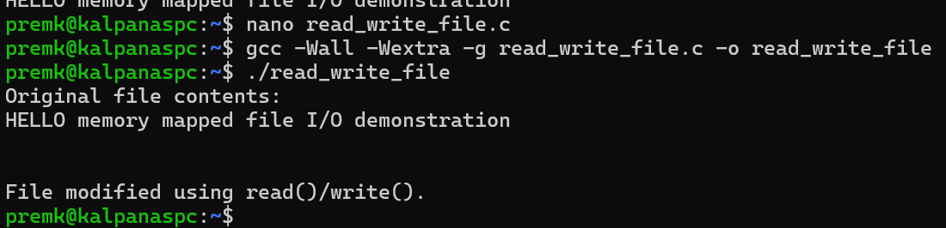

6. Fundamental Difference
Traditional I/O
read()
File ─────────────────→ User Buffer
|
↓
Application
|
↓
write()
|
↓
File
The application explicitly performs data transfers.
Memory-mapped I/O
mmap()
File ─────────────────────────→ Virtual Memory
|
↓
Application
|
data[i] = value
|
↓
msync()
|
↓
File
The application accesses the mapped region using normal memory operations.
7. Efficiency Comparison
For a fair comparison, create a sufficiently large file, for example:
dd if=/dev/zero of=test.dat bs=1M count=100
Compile both programs with optimization:
gcc -O2 -Wall -Wextra mmap_file.c -o mmap_file
gcc -O2 -Wall -Wextra read_write_file.c -o read_write_file
Measure execution time:
time ./mmap_file
and:
time ./read_write_file
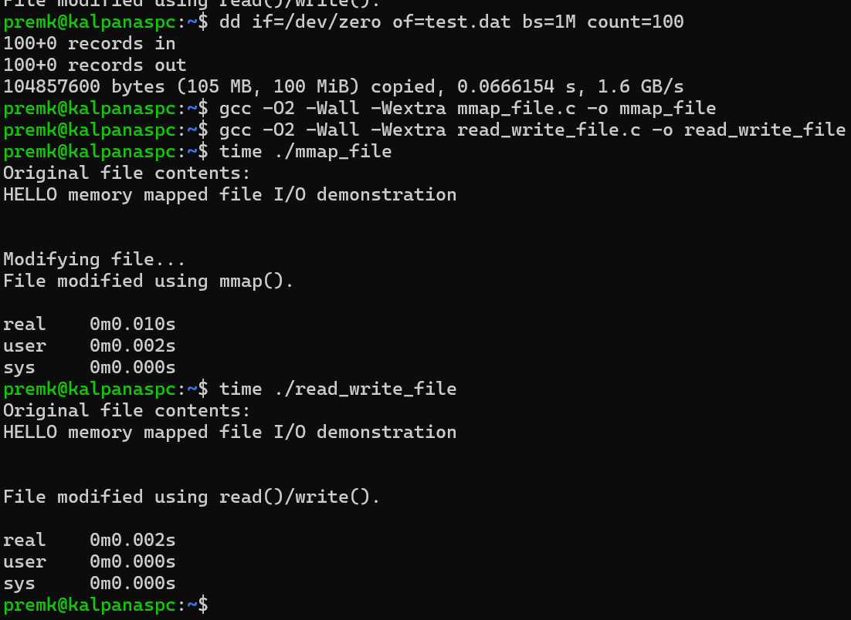
For a more meaningful experiment, implement both versions to process the same large file and perform the same operation, then repeat each test several times.
8. Comparison
Feature | read() / write() | mmap()
Basic mechanism | Explicit system calls | File mapped into virtual memory
Data access | Buffer-based | Memory-based
Programming model | More explicit | More natural for random access
System-call involvement | read()/write() calls | Initial mmap(); page faults handle access
Random access | Requires lseek() or offsets | Direct pointer indexing
Large-file processing | Straightforward | Very convenient
Partial I/O handling | Must be considered | Not handled as read()/write() transfers
Synchronization | write() transfers data | msync()/unmapping and OS write-back
Address-space usage | User buffer required | Mapping occupies virtual address space
Complexity | Simple for sequential I/O | More concepts to understand
Potential performance | Very good for sequential buffered I/O | Can be advantageous for repeated/random access
Portability | Very common | Also POSIX/Linux, but requires mapping support

